**Household Acids and Bases**

Many common household solutions contain acids and bases. Acid-base indicators, such as litmus and red cabbage juice, turn different colors in acidic and basic solutions. They can, therefore, be used to show if a solution is acidic or basic. An acid turns blue litmus paper red, and a base turns red litmus paper blue. The acidity of a solution can be expressed using the pH scale. Acidic solutions have pH values less than 7, basic solutions have pH values greater than 7, and neutral solutions have a pH value equal to 7. In this experiment, you will a pH Sensor to determine the pH values of household substances.

**OBJECTIVES**

In this experiment, you will

* Use a pH Sensor to determine the pH values of household substances.
* Identify which substances are acids or bases.

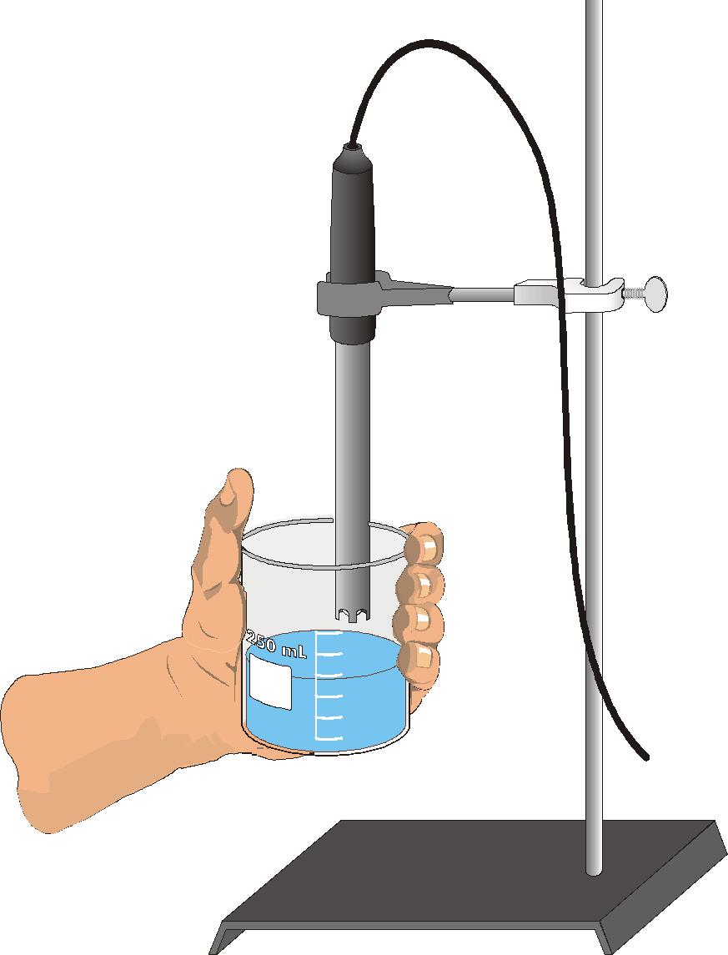

*Figure 1*

**MATERIALS**

|  |  |
| --- | --- |
| Sci-Voice Talking LabQuest | household solutions |
| Vernier pH Sensor | seven small test tubes |
| 250 mL beaker | test-tube rack |
| wash bottle | stirring rod |
| distilled water | paper towel |
| ring stand |  |
| utility clamp |  |
| sensor soaking solution |  |

**PROCEDURE**

1. Obtain and wear goggles. **CAUTION:** *Do not eat or drink in the laboratory.*

**Part I pH Tests**

2. Label 5 test tubes with the numbers 1–5 and place them in a test tube rack.

3. Measure 3 mL of vinegar into test tube #1. Refer to the data table and fill each of the test tubes 2–5 to about the same level with its respective solution.

4. Prepare the pH Sensor for data collection:

1. Connect the pH Sensor to a Sci-Voice Talking LabQuest.
2. Remove the pH Sensor from the sensor storage solution bottle by unscrewing the lid. Carefully remove the bottle, leaving the cap on the sensor body.
3. Rinse the tip of the sensor with distilled water and place the sensor tip into a beaker containing sensor soaking solution. Use a utility clamp to fasten the pH Sensor to a ring stand, as shown in Figure 1.

5. Raise the pH Sensor from the sensor soaking solution and set the solution aside. Use a wash bottle filled with distilled water to thoroughly rinse the pH Sensor. Catch the rinse water in a 250 mL beaker.

6. Obtain one of the 5 solutions in the small container supplied by your teacher. Raise the solution to the pH Sensor and swirl the solution about the sensor. When the pH reading stabilizes, record the pH value.

7. Prepare the pH Sensor for reuse:

1. Rinse it with distilled water from a wash bottle.
2. Place the sensor into the sensor soaking solution and swirl the solution about the sensor briefly.
3. Rinse with distilled water again.

8. Determine the pH of the other solutions using the Step 6 procedure. You must clean the pH Sensor between tests using the Step 7 procedure.

9. When you are finished, rinse the sensor with distilled water and return it to the sensor soaking solution.

**Part II Neutralization**

10. Now take one acid and add one third of the solution to one of the basic solutions. Then Record the pH of the solution as you did before in step 6. You must clean the pH sensor as you did in step 7.

11. Take a basic solution and add one third of it to an acidic solution and once again record the pH as you did in step 6, followed by cleaning it as you did in step 7.

12. Now obtain 3 ml portions of two acids and add them together. Record the pH and then clean the pH sensor.

13. As you did in step 12, gather two bases and record the pH with the pH sensor, followed by cleaning the sensor.

**PROCESSING THE DATA**

1. Which of the household solutions tested are acids? How can you tell?

2. Which of the solutions are bases? How can you tell?

3. What happened when an acid was added to a base?

4. What happened when a base was added to an acid?

5. What happened when acid was added to an acid?

6. What happened when base was added to a base?

**DATA TABLES**

|  |  |  |
| --- | --- | --- |
| Table 1 | | |
| Test tube | Solution | pH |
| 1 | Vinegar |  |
| 2 | Lemon juice |  |
| 3 | Soft drink |  |
| 4 | Drain cleaner |  |
| 5 | Baking soda |  |

|  |  |
| --- | --- |
| Table 2 | |
| Acid and base used | pH of solution |
|  |  |
|  |  |
|  |  |
|  |  |
|  |  |